#VIOLIN NOTES REVIEW.
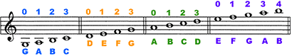

VIOLA NOTES REVIEW.
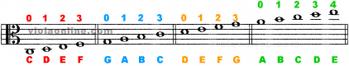
CELLONOTES REVIEW.
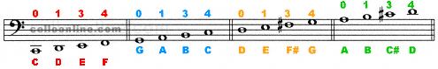
BASS NOTES REVIEW
